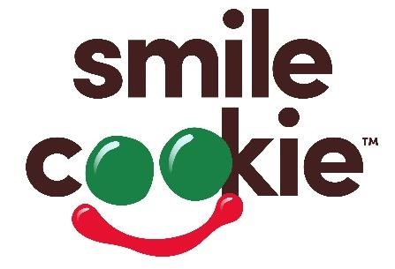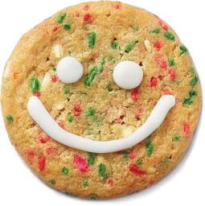 2022 Pre-Order Form

From December 5 - 11, Tim Hortons Restaurant Owners in Saskatoon will be supporting St. Paul’s Hospital Foundation. Guests who purchase a freshly baked Holiday Smile Cookie will be donating to St. Paul’s Hospital Foundation with 100% of proceeds being donated! To pre-order Tim Hortons Holiday Smile Cookies, complete this form and submit it to your nearest participating Tim Hortons Restaurant no less than 48 hours of your specified pick-up date & time. Or visit the Tim Hortons app, Uber Eats or Skip the Dishes to see if your Holiday Smile Cookies can be delivered.

Number of Cookies: |  | 12 Cookies per box

Your Name:
Address:
 | Telephone: | ( )
 | Email:

Pick Up Date: |  | Pick Up Time:

Thank you for your support!

